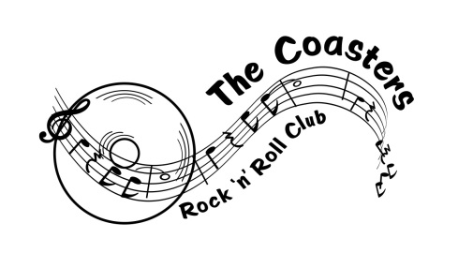

The Coasters Rock ‘n’ Roll Club Inc
Membership Application/Renewal 2017

Name……………………………………………………………………………
Contact Address…………………………………………………………......
Mobile………………………………………………………………………….
Email……………………………………………………………………………
Birthday……………………………………………………………………

Condition of entry
I accept there is an inherent risk in any physical activity, including rock and roll dancing.
I accept full responsibility for any injury that I may sustain while rock and roll dancing as a member or guest of the Coasters Rock ‘n’ Roll Club Inc.
I undertake to limit this risk by making club executive aware of any injuries or illness and by taking reasonable steps to limit the risk of further illness or injury.

Declaration
I undertake to abide by the rules and constitution of the Coasters Rock ‘n’ Roll Club Inc and understand that voting rights are only granted to financial members.

Publicity
I give/do not give permission for my image to be used for publicity purposes in print and/or digital media.

Annual subscription due 1 April.

Signed…………………………………………. Date…………………………

Office use: Date joined: ……………………………… Paid………………………………

